**Background:**

* 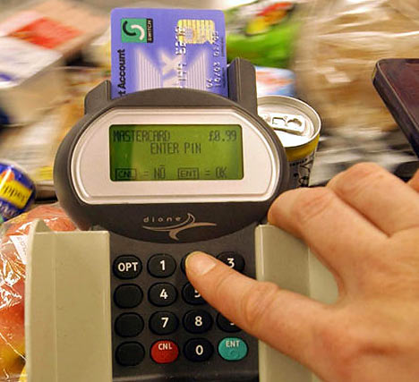PINs (Personal Identification Numbers) are used in a wide   
  range of security applications.
* Four digit PINs (e.g. 1234) are the most common as they are   
  convenient and provide some security. However, six digit PINs   
  (e.g. 123456) should be used whenever possible for improved   
  security.

**Assignment:**

1. Write a simple program that does the following:
   1. Asks the user to enter a 4 digit PIN. This will be the target PIN that the program   
      will try to “crack”.
   2. Runs a loop that starts at 1 and stops when the target PIN is found.
2. Enhance your basic program to include the following code:
   1. The purpose of this code is to measure how long it takes to “crack” the pin.
   2. On average, how long does it take to “crack” a PIN? Try several combinations.

import time

startTime = time.time()

loopCount = 1

while (loopCount <= 1000) :

loopCount = loopCount + 1

endTime = time.time()

print("Elapsed time is:", (endTime - startTime) )

1. Many people use insecure PINs that contain repeated digits such as “1111” or simple sequences such as “1234”.
   1. Enhance your program to try some different digit repeats or digit sequences in order to crack the PIN faster.
   2. Include your enhancements before the main loop.
   3. How does this affect the time needed to “crack” a PIN?
2. Research some other ways that people choose insecure PINs. (e.g. birthday dates)
   1. Enhance your program to check for some of these insecure patterns.

import time

startTime = time.time()

loopCount = 1

while (loopCount <= 1000) :

loopCount = loopCount + 1

userPin = int(input('\u001b[35m'"Please enter a 4 digit PIN: "))

pin2 = userPin - 1

if (userPin < 10000) and (userPin > 1000) :

if (userPin == 1111) or (userPin == 1000) or (userPin == 1234) or (userPin == 2004) or (userPin == 9999) or (userPin == 6666) or (userPin == 0000) or (userPin == 2019) :

if (userPin == 1111) :

print ('\u001b[36m'"Your pin is 1111")

if (userPin == 1000) :

print ('\u001b[36m'"Your pin is 1000")

if (userPin == 1234) :

print ('\u001b[36m' "Your pin is 1234")

if (userPin == 2004) :

print ('\u001b[36m'"Your pin is 2004")

if (userPin == 9999) :

print ('\u001b[36m'"Your pin is 2000")

if (userPin == 6666) :

print ('\u001b[36m'"Your pin is 6666")

if (userPin == 0000) :

print ('\u001b[36m'"Your pin is 3000")

if (userPin == 2019) :

print ('\u001b[36m'"Your pin is 4000")

else :

count = 1

while (True) :

print ('\u001b[36m'"Get ready", count)

if (count >= pin2) :

break

else :

count = count + 1

print ("Your pin is",userPin)

endTime = time.time ()

print('\u001b[31m'"Elapsed time is:", (endTime - startTime))

1. Explain how the use of a six digit pin would increase security. Refer to some of the things you discovered while writing the programs for this assignment.

This will increase security as the people who try to crack your password will have more possible combinations to guess or crack, and the programs will take longer to figure out the pin.